**SMART GREEN HOUSE SYSTEM**

**MINI PROJECT REPORT**

***Submitted by***

**GOWTHAMAN S (822221106017)**

**KISHORE M (822221106023)**

**RAJARAJAN R (822221106031)**

**SAKTHIVEL R (822221106033)**

**SENTHILRAJA V (822221106037)**

**ET3491-Embedded Systems and IOT Design**



**Electronics and Communication Engineering**

**University College of Engineering, Thirukkuvalai**

**(A Constituent College of Anna University, Chennai)**

**Nagapattinam-District**

**ABSTRACT**:**-**

This project presents the development and implementation of a smart green house system utilizing Arduino microcontroller and sensors. Greenhouse agriculture is a promising approach to evaluate alternatives to improve water efficiency since the different variables can be monitored within a controlled environment. The system integrates an humidity sensor and moister sensor and relay model. Soil moisture measures the amount of available water for the crops, while the vegetation index indicates the healthiness level of the plants.

The project aims to optimize Greenhouse, being a closed structure protects the plants from extreme weather conditions namely: wind, hailstorm, ultraviolet radiations, and insect and pest attacks. The irrigation of agriculture field is carried out using automatic drip irrigation, which operates according to the soil moisture threshold set accordingly so as optimal amount of water is applied to the plants.

**PROJECT REQUIREMENTS:-**

* **Software:-**
* Tinker cad(simulation)
* Arduino Ide
* Fritzing(circuit diagram)
* **Hardware :-**
* Arduino Uno R3
* Soil Moisture sensor
* Humidity sensor
* Relay model 12v
* DC motor 3-9v
* Bread Board and Jump Wires
* Power sources

**IMPLEMENTATION:**

Building a smart greenhouse involves a few key steps to ensure plants grow well without much manual work. First, you need to pick the right sensors to keep track of things like temperature, humidity, light, and soil moisture. You'll also need gadgets like fans, heaters, and water pumps to control the environment. Then, you use a small computer, like an Arduino or Raspberry Pi, to connect everything and make decisions based on the sensor readings.

Next, you have to put the sensors in the right places inside the greenhouse. Temperature and humidity sensors should be spread out to capture different climate zones, while light sensors help you see how much sunlightyour plants get.

Soil moisture sensors should be placed strategically to check if your plants need water.

Once you've set up the sensors, you connect the actuators, like fans and water pumps, to control the environment. For example, fans can help cool things down, heaters can warm them up, and water pumps can give your plants a drink when the soil is dry.

After that, you decide what actions to take based on the sensor readings. You might set up simple rules like "if it's too hot, turn on the fan" or "if the soil is dry, water the plants." You can also schedule tasks like watering your plants at specific times.

To keep track of what's happening, you log the sensor readings over time and use graphs or charts to see how things change. You can even make a phone app or website to check on your greenhouse from anywhere and get alerts if something's wrong.

Lastly, you test your smart greenhouse, make adjustments as needed, and keep an eye on how well things are working. With a bit of tweaking, you'll have a smart greenhouse that takes care of your plants automatically, making gardening easier and more efficient.

**BENEFITS**:

**Protection From External Conditions**

* Prevents risks of unpredictable weather conditions, pest damage and diseases
* Increases resource efficiency whilst reducing use of pesticides

**Infrastructure for Precision Agriculture**

* Optimises growing parameters based on yield quantity and quality, increasing crop production densities

**Responsive Greenhouse Environment**

* Increases energy efficiency due to adaptable interior climate in response to crop and exterior conditions

**Remote Access & Control**

* Automated monitoring, climate control and fertigation systems minimises human intervention and reduces labour costs

**TINKER CAD SIMULATION:-**

* **FRITZING SOFTWARE CIRCUIT DIAGRAM**

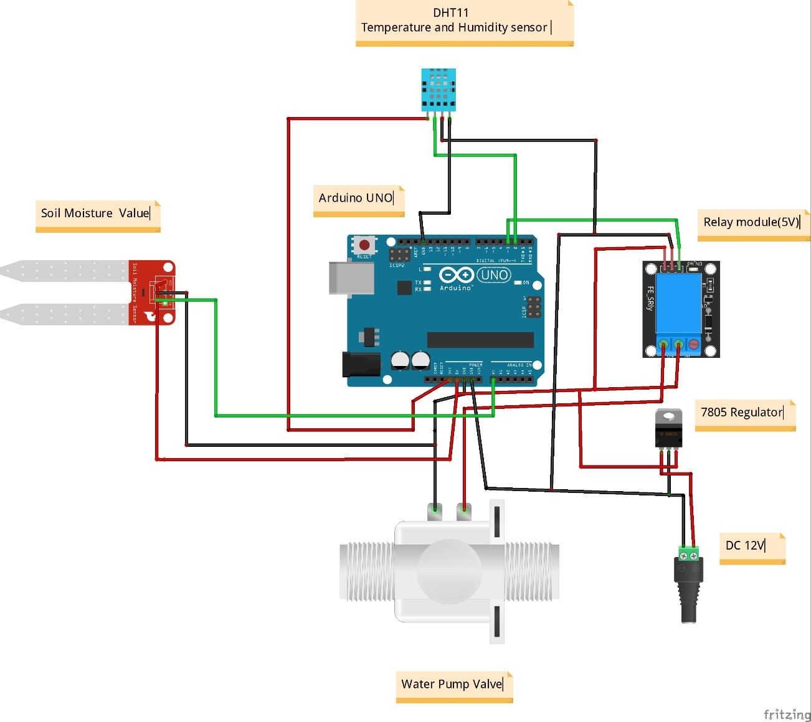

**SCHEMATIC VIEW:-**

* **CIRCUIT DIAGRAM SCHEMATIC VIEW**

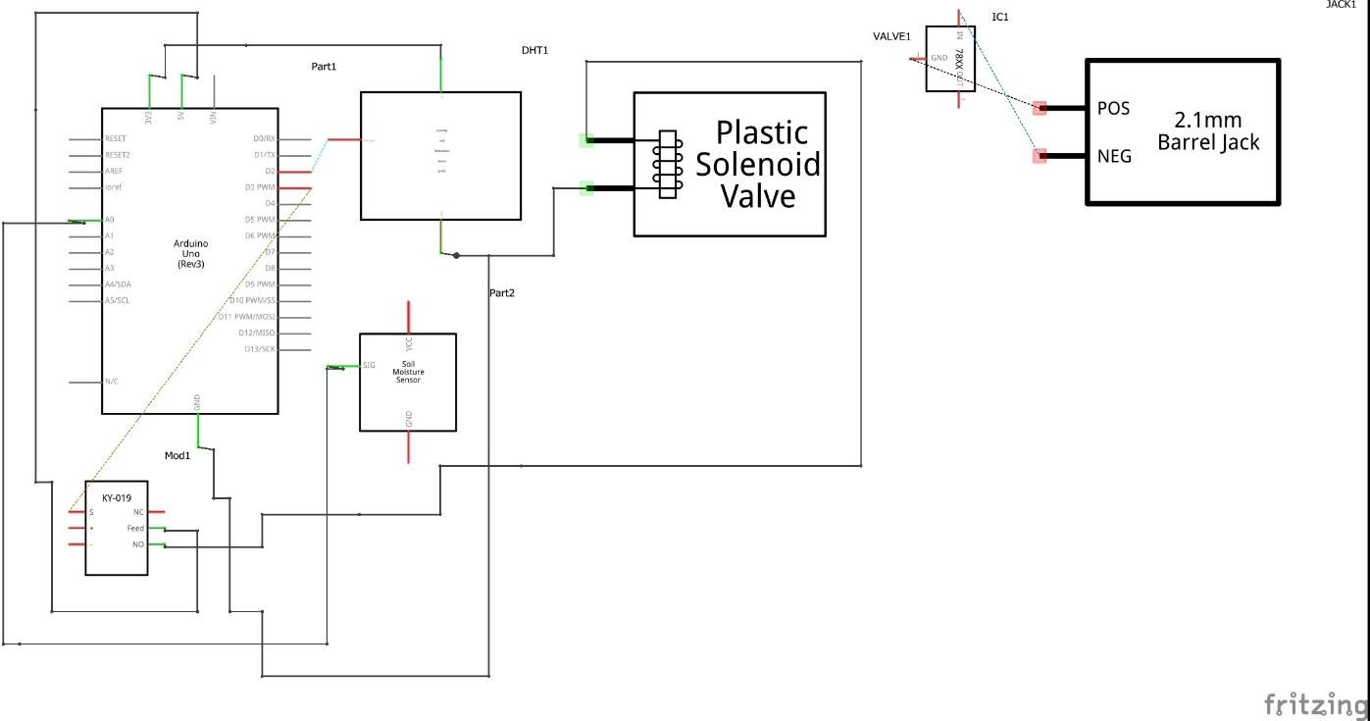

**HARDWARE SIMULATION:-**

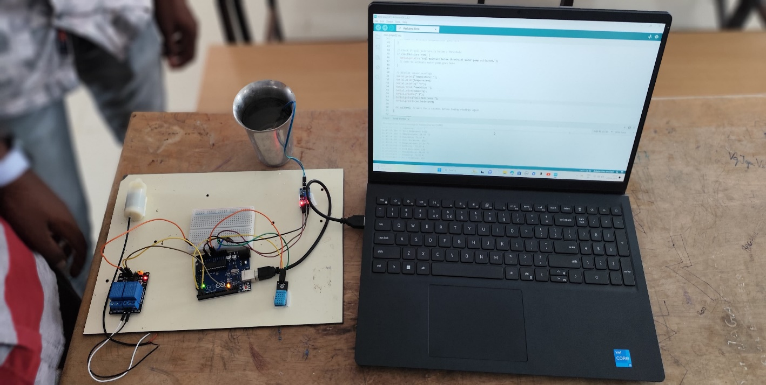

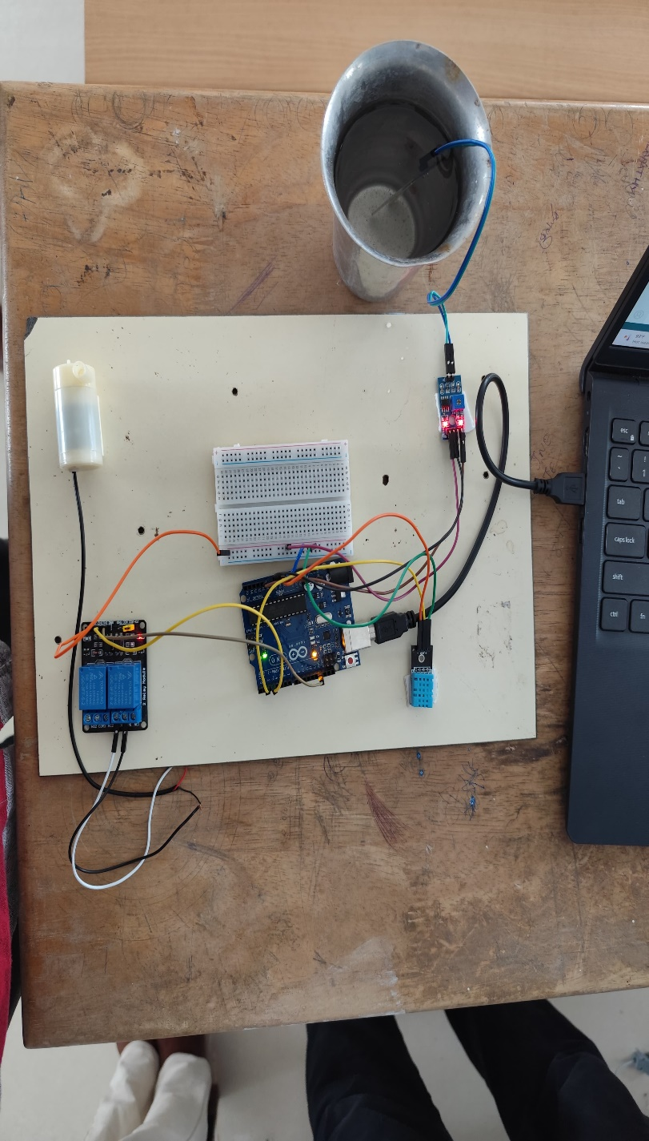

**PROGRAM:-**

#include <DHT.h>

#include <SoftwareSerial.h>

#define DHTPIN 2 // Digital pin connected to the DHT sensor

#define DHTTYPE DHT11 // Type of DHT sensor

SoftwareSerial espSerial(RX, TX); // RX, TX

DHT dht(DHTPIN, DHTTYPE);

const int soilMoisturePin = A0; // Analog pin connected to the soil moisture sensor

const int pumpPin = 3; // Digital pin connected to the relay module

float temperatureLimit = 100.0; // Temperature limit in Celsius

float humidityLimit = 100.0; // Humidity limit in percentage

void setup() {

Serial.begin(9600);

espSerial.begin(9600);

pinMode(pumpPin, OUTPUT);

digitalWrite(pumpPin, LOW);

dht.begin();

}

void loop() {

float temperature = dht.readTemperature();

float humidity = dht.readHumidity();

int soilMoisture = analogRead(soilMoisturePin);

// Check if temperature exceeds the limit

if (temperature > temperatureLimit) {

Serial.println("Temperature exceeds limit! Cooling system activated.");

// Code to activate cooling system goes here

}

// Check if humidity exceeds the limit

if (humidity > humidityLimit) {

Serial.println("Humidity exceeds limit! Dehumidifier activated.");

// Code to activate dehumidifier goes here

}

// Check if soil moisture is below a threshold

if (soilMoisture >500) {

Serial.println("Soil moisture below threshold! Water pump activated.");

// Code to activate water pump goes here

}

// Display sensor readings

Serial.print("Temperature: ");

Serial.print(temperature);

Serial.println(" °C");

Serial.print("Humidity: ");

Serial.print(humidity);

Serial.println(" %");

Serial.print("Soil Moisture: ");

Serial.println(soilMoisture);

delay(2000); // Wait for 2 seconds before taking readings again

**CONCLUSION:-**

The smart green house system developed in mini-project successfully created a smart irrigation system using basic components like an Arduino Uno, soil moisture sensor, relay module, and water pump. The system effectively monitors soil moisture levels and activates the water pump when needed, ensuring plants receive adequate watering.

Throughout the project, we tackled challenges such as setting up hardware connections and calibrating sensor thresholds. By troubleshooting and experimenting, we overcame these obstacles and achieved a functional system.

Looking ahead, there's room for further enhancements like remote monitoring and adding more sensors for better environmental data collection. Our project highlights the potential of simple technology solutions to address agricultural needs and promote sustainable practices in farming.